BERESFORD, Michelle
mbere6@eq.edu.au
Abstract
This document outlines the ways in which Eulo State School and the Eulo and surrounding community engage with each other to enhance learning for our students.
Parent and community engagement framwork
Eulo State School – 2017 - 2018
Parents and Community Engagement Framework
For
Eulo State School
2017

Contents
Introduction 2
Communication 3
Learning Partnerships 4
Community Collaboration 5
Decision Making 6
Participation 7
Appendix 1 – Early Years Strategic Plan 8
Appendix 2 – AAP Action Plan 13

Introduction
The education of our students is a shared responsibility, benefiting all students, our society and economy as a whole. Therefore, parents and broader communities have a reciprocal responsibility to engage with schools. Schools are better able to support student achievement by developing strong engagement with and between:
• students
• teachers
• parents and carers
• support staff
• community, industry and business groups.
Queensland Government (2014) Parent and Community Engagement Framework: Working together to maxamise student learning.
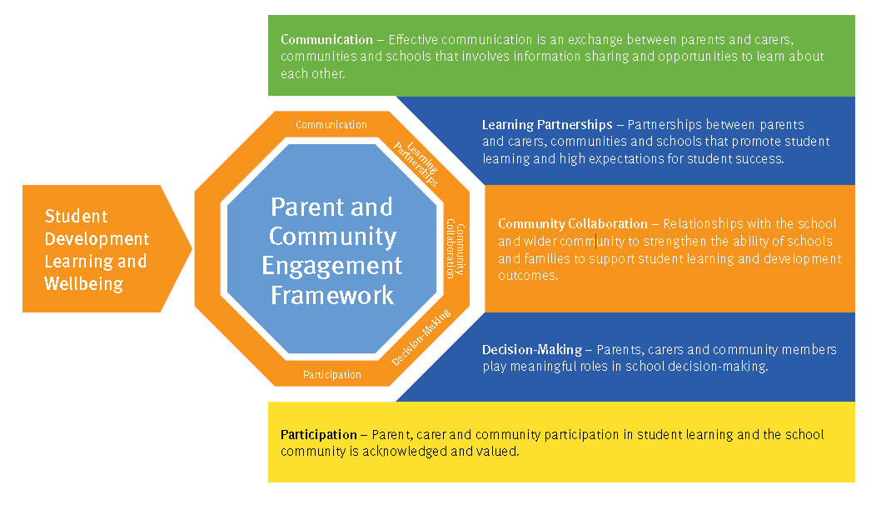
At Eulo State School, it is a matter of pride within the community that the school and community work in partnership to promote and support the education and well-being of all our students. This document outlines which current practises occur to ensure the success of these partnerships, and what the plans are for future years.
As supported by the “Parent and Community Engagement Frameworks”, parents are encouraged to take a genuine interest in the working of the school, and provide opinions and recommendations that will benefit student learning and well-being. By acknowledging that parents and grandparents are the first teachers of their children/grandchildren, we also acknowledge they are the primary source of information about their child. At Eulo State School, parent and family interest, and participation is highly valued, supported and expected for the smooth running and continual and progressive development of our children.

Communication
To support ongoing communication between Eulo State School and the community, Eulo State School staff will:
- Provide information about the running of the school, school events, student awards through the school newsletter. This will be sent home with students, emailed to those community members who have indicated a wish to receive the newsletter, and uploaded to the school website.
- Attend P&C meetings and share policy and framework documents with the P&C.
- Provide parent information sessions on how/what we are teaching at school.
- Embed an open door policy for parents and carers, that supports open, honest discussions about their children.

Learning Partnerships
The partnerships currently supported within the Eulo and surrounding communities includes:
- Enrolment of Year 5 and 6 students in BSDE for Japanese
- Attendance at Professional Development opportunities through the Cunnamulla Library, surrounding schools, cluster events
- Involvement of students in community events that enhance the curriculum such as ANZAC day ceremony, Music In the Mulga, Small Schools Great Schools, Cunnamulla Fella Festival, Sports Camp
- Staff professional development around the use of the Literacy Continuum, QKLG, SSP and other relevant programs
- Playgroup
- KEYS
- Transition to school
Community Collaboration
Eulo State School will collaborate with the community to enhance student learning and development by:
- Ensuring protocols for events in which the school participates, are accurate and respectful.
- Engage in community feedback around the review of school policies such as the Responsible Behaviour Plan
- Participating in local and community events
- Working with a community facilitator to provide Eulo Playgroup
- Inviting community to engage in school functions being held in Eulo, such as District Cross Country

Decision Making
School decision making will take into account parent, carer and community opinion and involve decisions around events such as:
- School leadership roles
- Maximising second teacher allocation to school through school funding
- Student participation in some decisions such as playground use, uniform, preferred resources that enhance the presentation of Australian Curriculum
- P&C events and fundraising

Participation
Parent participation is not only valued, but essential to smooth running of a small school. They are encouraged to support:
- Swimming lessons by providing transport
- Attendance at school camp
- Engagement routine school maintenance
- Upskilling community members and staff in the upkeep of the school website
- Attending information sessions
- District events held at Eulo eg. KEYS, Cross Country, Music in the Mulga

Appendix 1
Early Years Strategic Plan
(2017)
