The requirements for curriculum provision to gifted and talented students are specified in the P-12 curriculum, assessment and reporting framework; additional information is provided below.
Defining ‘gifted’ and ‘talented’
The following definitions reflect the distinction between potential and performance. They recognise the factors involved in developing a student’s giftedness into talent.
Gifted students are those whose potential is distinctly above average in one or more of the following domains of human ability: intellectual, creative, social and physical. Giftedness designates the possession and the use of outstanding natural abilities, called aptitudes, in at least one ability domain, to a degree that places an individual at least among the top 10% of age peers in the school.
Talented students are those whose skills are above average in one or more areas of performance. Talent designates the outstanding mastery of abilities over a significant period of time. These are called competencies (knowledge and skills). Outstanding mastery is evident in at least one field of human activity to a degree that places an individual at least among the top 10% of age peers in the school who are or have been active in that field.
Collaborative management of curriculum provision
A collaborative team approach is used in the management of curriculum provision to gifted and talented students to provide consistent and continuous identification processes school-wide. This team oversees the support of student learning and:
- establishes identification and provision processes for gifted and talented students at the school
- monitors these processes
- negotiates and endorses a course of action for each student
- establishes a school-wide process for determining whether acceleration (year advancement) is appropriate when planning provision for a student already identified as gifted and talented and whose needs are not being met through differentiation and enrichment.
- ensures the maintenance of ongoing monitoring and comprehensive records.
As appropriate to the school context, this team provides a range of expertise and could include:
- the principal (or other school administrator)
- a teacher with expertise in gifted and talented education
- teachers who have undergone professional development in gifted and talented education
- the Guidance Officer
- Support Teacher (Literacy and Numeracy).
In small schools, or in rural/remote areas, the team may include personnel working across a cluster of schools or at regional level.

Identification
Teachers plan for the fact that students who are gifted or talented in one or more domains are present in every school. These students are identified, using data from a range of sources. The identification process ensures gifted and talented students are not educationally disadvantaged on the basis of racial, cultural or socio-economic background, physical or sensory disability, geographical location or gender.
Knowledge of the characteristics of gifted and talented students (described in Attachment 1) will assist teachers to identify and support these students with appropriate strategies.
A recommended process for identification is described in Attachment 2.

Curriculum provision
For gifted and talented students, teachers deliver the curriculum at a level, pace, degree of abstraction and complexity beyond learning expectations for their age peers. Curriculum provision for gifted and talented students addresses their specific learning needs such as:
- a faster pace
- processing more complex information and use of higher order thinking
- opportunities to engage in learning with students of the same or higher ability
- opportunities to undertake challenging work which enables them to develop strategies for persevering with difficult problems.
Many gifted and talented students can be catered for through a differentiated curriculum and through enrichment. However, for those whose needs are not being met through differentiation or extension, other options such as acceleration are considered. Further advice is provided in A whole school approach to support student learning.
Acceleration to a higher year-level curriculum
For highly gifted students, accelerated progression to a higher year-level curriculum may be appropriate ─ either in one or more subjects or for the full curriculum. A useful process for considering acceleration is described in Attachment 3.
Decisions regarding the provision of a higher year-level curriculum and achievement standard, in one or more subjects/learning areas are:
- based on quantitative and qualitative evidence that it is appropriate for this student
- made in consultation with parents (and students where appropriate)
- reviewed following a minimum of six weeks trial of the accelerated placement (to ensure that the placement matches the needs, interests and abilities of the student).
Provision of a higher year-level curriculum may involve:
- learning area/subject acceleration
- full year-level acceleration (year advancement or ‘accelerated progression’).
This provision is documented in an Individual Curriculum Plan. The recommended process and content of this plan is provided in A whole school approach to support student learning.
Acceleration to Senior secondary
For students accelerated to senior secondary for one or more subjects or for full year-level advancement, schools comply with Queensland Curriculum and Assessment Authority (QCAA) moderation and certification procedures.
The QCAA term Variable progression rate (VPR) includes accelerated students. All VPR students must:
- be part of a cohort that is subject to the processes of QCAA senior externally moderated, school-based assessment
- complete moderation processes with the cohort with whom they study the subject
- be included on Forms R6 and/or Forms R12 with the subject cohorts with whom they exit their school at the completion of Year 12.
The above requirement and further procedures for schools are specified in the QCAA’s A–Z of Senior Moderation (Section 3.4 page 48).

Reporting to parents
Students are assessed and reported against the achievement standard for the year-level curriculum they are taught.
Students who have been accelerated receive reports on their achievement against the achievement standard for the year-level curriculum taught. The year-level curriculum will have been identified in their Individual Curriculum Plan and previously agreed by parents.
For students provided a higher year-level curriculum in one or more learning areas/subjects (but not the whole curriculum) teachers create a report using the OneSchool SER module. In the comments section of the OneSchool report template teachers indicate the particular year-level curriculum that the student has been provided, for each learning area/subject, during that reporting period. (This provision will have been previously negotiated with parents.)
Students who are fully accelerated to a higher year level are reported on as part of that year-level cohort. For example, a Year 8 student who is fully accelerated to Year 9 will receive a report of their achievement against Year 9 curriculum and as part of the Year 9 cohort.

Documentation
The school maintains ongoing records of all students identified as gifted and talented. Records include:
- identification process
- curriculum provision
- communication with parents and others across the years of schooling.
These records can be maintained in OneSchool.

Attachment 1

Characteristics of gifted and talented students
Students who are gifted and talented in one or more domains are present in every school and across all groups of learners, including:
- underachievers
- students requiring learning support
- students with disability
- students from non-English speaking backgrounds
- students from culturally diverse backgrounds
- socio-economically disadvantaged students
- geographically isolated students.
It is important for all teachers, principals, guidance officers, as well as parents to be aware of the characteristics of gifted students so that these students are identified and supported with appropriate strategies.
Typical characteristics which may indicate giftedness include:
- Shows superior reasoning powers and marked ability to handle ideas; can generalise readily from specific facts and can see subtle relationships; has outstanding problem-solving ability.
- Shows persistent intellectual curiosity; asks searching questions; shows exceptional interest in the nature of man and the universe.
- Has a wide range of interests, often of an intellectual kind; develops one or more interests to considerable depth.
- Is markedly superior in quality and quantity of written and/or spoken vocabulary; is interested in the subtleties of words and their uses.
- Reads avidly and absorbs books well beyond his or her years.
- Learns quickly and easily and retains what is learned; recalls important details, concepts and principles; comprehends readily.
- Shows insight into arithmetical problems that require careful reasoning and grasps mathematical concepts readily.
- Shows creative ability or imaginative expression in such things as music, art, dance, drama; shows sensitivity and finesse in rhythm, movement, and bodily control.
- Sustains concentration for lengthy periods and shows outstanding responsibility and independence in classroom work.
- Sets realistically high standards for self; is self-critical in evaluating and correcting his or her own efforts.
- Shows initiative and originality in intellectual work; shows flexibility in thinking and considers problems from a number of viewpoints.
- Observes keenly and is responsive to new ideas.
- Shows social poise and an ability to communicate with adults in a mature way.
- Gets excitement and pleasure from intellectual challenge; shows an alert and subtle sense of humour.
Note: Not all gifted students will display all of these characteristics, all of the time.
Attachment 2

Identification — a recommended process
Use a team approach to provide consistent and continuous identification processes school-wide.
The following four-step identification process ensures data-collection processes are reliable and valid.

The information gathered from the first two steps, below, is used to create a profile of the student. This profile is used to refer the student to the school support team. It informs decisions about how best to support the student’s learning.
1. Teachers use current data from school-based screening and assessment | Teachers collect data on all students from school-based screening and assessment.  Use data from a range of sources which show the student’s current performance e.g.  - screening tests  - standardised tests  - teacher created tests  - NAPLAN (as an additional data source).
2. Teachers collect data using checklists for gifted and talented | Gather a range of evaluative judgments about the student by using checklists with parents, teachers, peers and the students themselves.
3. Guidance Officer and classroom teacher collect data using ability and academic assessments | Off-level testing – Support Teacher (Literacy and Numeracy) or classroom teacher:  - applies standardised tests as in school-based screening (Step 1) but at a level above the current grade of the student  - identifies the extent of a student’s knowledge or skill in an area of giftedness or talent.  Aptitude tests measure a student’s potential to perform well academically. These tests assess performance in school-based tasks. Some aptitude tests can only be administered by Guidance Officers. Request advice from regional Senior Guidance Officer.
4. Guidance Officer collects data using cognitive assessments | IQ or cognitive assessment or other assessment as deemed necessary by the school guidance officer to:  - provide information on a student’s potential to perform well academically  - establish level of giftedness and talent for appropriate provision  - determine suitability for accelerated or special placement.

Attachment 3

Acceleration
Acceleration allows gifted and talented students to progress through an educational program at a faster rate than their age peers.
Acceleration can be provided through:
- Ability groupings within the class — may work on higher year-level curriculum for some learning areas, in regular classroom setting.
- Curriculum compacting — the purpose of curriculum compacting is to reduce the amount of repetition that the student receives. Pre-assessment determines year level proficiency in a learning area and enables the teacher to provide enrichment or accelerated options.
- Telescoping the curriculum which involves reducing the time a student, or group of students, take to complete the school curriculum, for example, completes one year in a semester or three years in two.
- Subject acceleration — in one or more learning areas. This can occur within the school, across primary and secondary schools, or across a secondary school and a tertiary institution.
- Year-level skipping — placement at a higher year level for the whole curriculum.
- Radical acceleration — placement at a year level that is two or more years higher than current placement.
- Early entry to Prep, secondary or tertiary education.
Acceleration can address particular students’ need for a faster pace of learning. However differentiation of content, process, product and learning environment is still required, to address the student’s overall learning needs. Carefully planned acceleration works for appropriately identified students, in well-prepared settings.
A recommended process for considering year level advancement
The steps outlined in the Process for Acceleration (see Page 7) are useful to determine whether, or not, year level advancement is appropriate for a student already identified as gifted and talented and whose needs are not being met through differentiation and enrichment.
Guidelines for developing an Academic Acceleration Policy is a useful resource to support the process for acceleration.
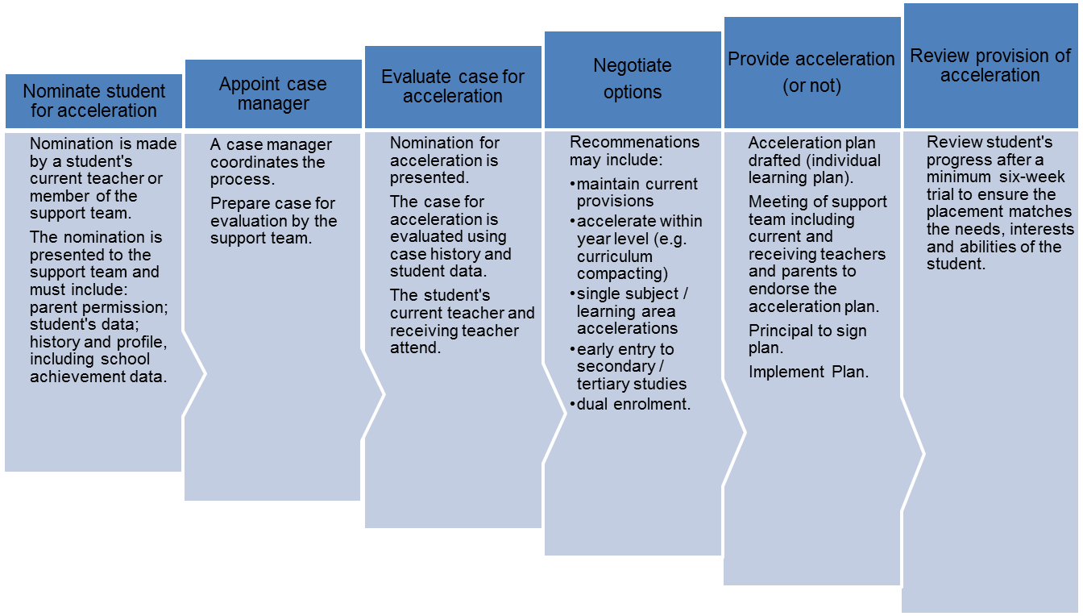
Process for Acceleration

Gagné, F. Transforming gifts into talents: The DMGT as a developmental theory. In N. Colangelo & G.A. Davis (Eds.), Handbook of gifted education (3rd ed., pp. 60–74).Boston: Allyn & Bacon, 2003. Gagné, F. Building gifts into talents: Brief overview of the DMGT2.0 paper presented at QAGTC lecture April 2008.
http://www.nagc.org/resources-publications/resources/my-child-gifted/common-characteristics-gifted-individuals
Colangelo et al Guidelines for developing an Academic Acceleration Policy 2009

