Michelle Beresford
mbere6@eq.edu.au
Abstract
“Wellbeing is a state in which every individual realises his or her potential, can cope with the normal stresses of life, can work productively and fruitfully and is able to make a contribution to his or her community.” – World Health Organisation
Eulo State School Learning and Wellbeing framework
2018
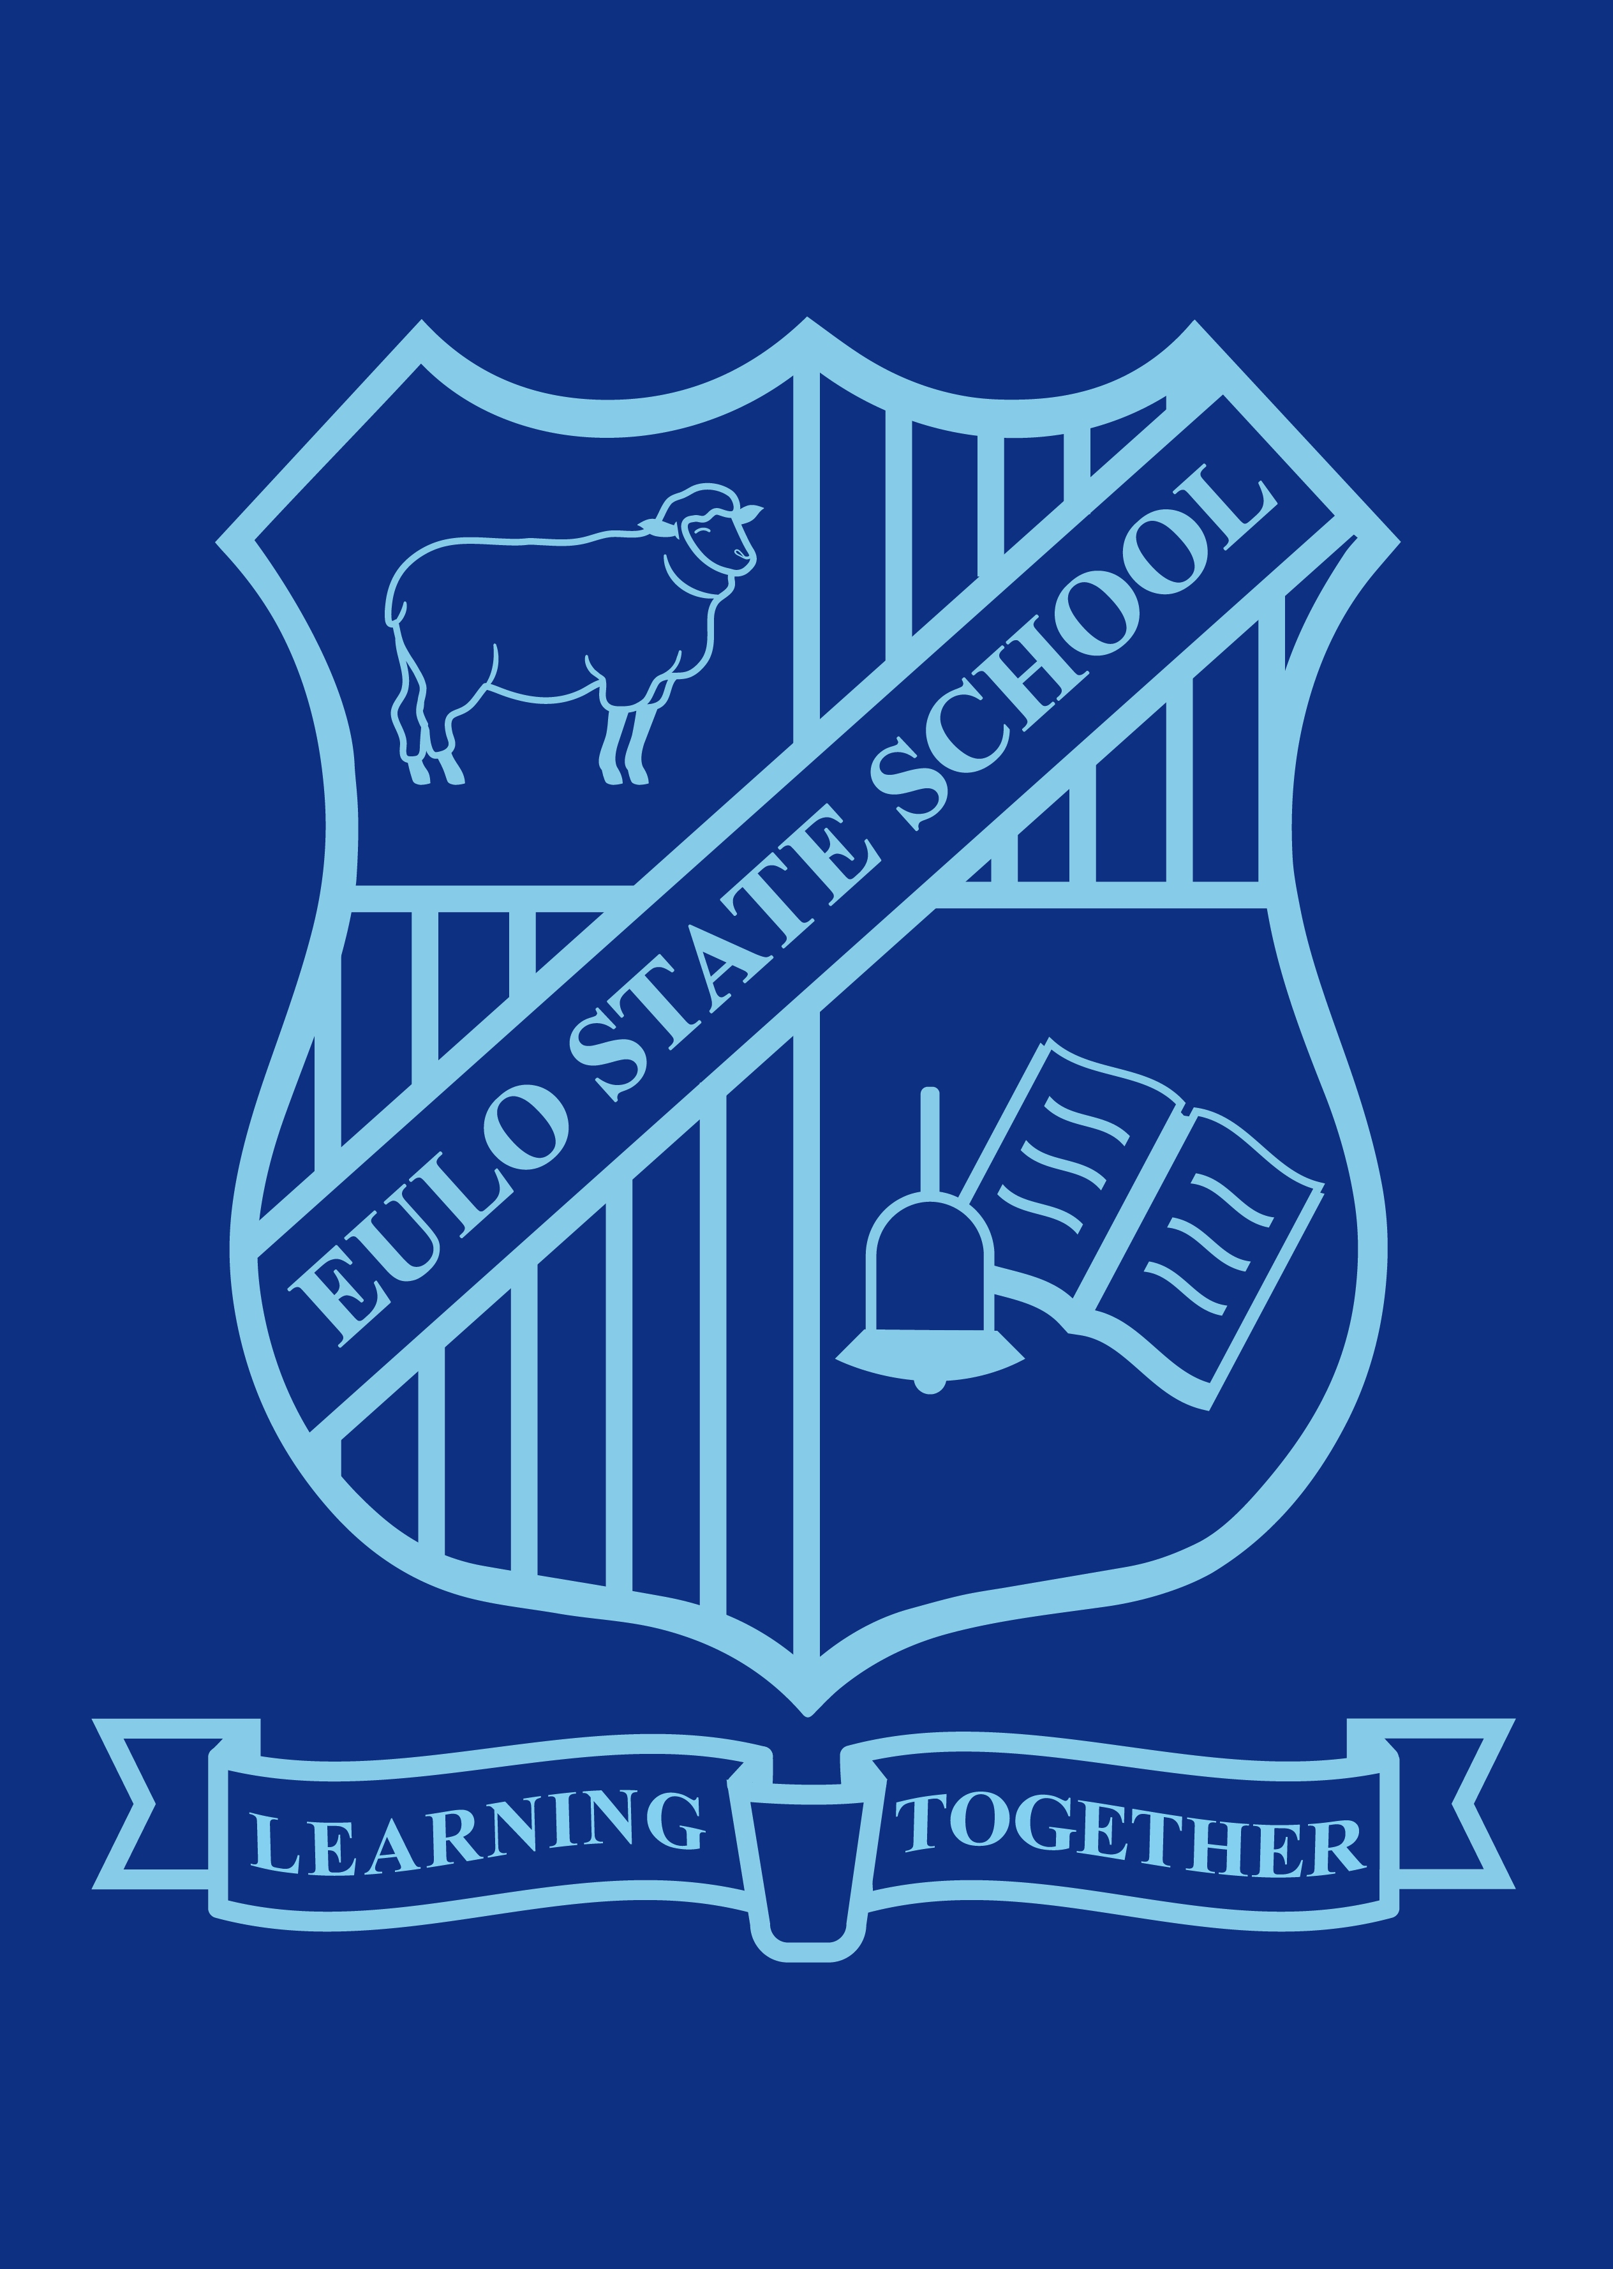

Eulo State School Student Learning and Wellbeing Framework
“Wellbeing is a state in which every individual realises his or her potential, can cope with the normal stresses of life, can work productively and fruitfully and is able to make a contribution to his or her community.” – World Health Organisation

Wellbeing – connected to learning
Our young people are growing up in a world driven by new technologies and economic globalisation. Their future means they need a new set of cognitive, social and emotional skills for success.
Healthy, confident and resilient young people who can successfully navigate a more complex world are vital for Queensland’s future.
We know that a supportive environment that combines a focus on wellbeing with a focus on learning is optimal — without one, the other will not happen.
Responding to individual and group differences, promoting collaborative learning, connecting to the hearts and minds of every student, and teaching students how to manage their wellbeing, are just some of the ways our teachers are making sure students thrive.
Our state schools must continue to provide inclusive environments that nurture the wellbeing of all students so they become resilient lifelong learners who respond positively to their changing world and pursue their passions with confidence.

Wellbeing – our approach
- Psychological
- Physical
- Personal
- Social
- Cognitive
Teachers—Providing inclusive learning environments that support every student to manage their wellbeing and achieve success
School leaders—Creating a whole school approach that provides the right conditions to achieve excellence and lift learning outcomes
School community—Strengthening connections with parents, support services and the wider community

Wellbeing – measuring success
Eulos State Schools monitors our school culture and student wellbeing and engagement through:
- attendance rates
- student retention data
- learning days lost due to student disciplinary absences
- School Opinion Survey responses.
The department is developing a standardised measure of wellbeing that will provide data on the state of wellbeing of students across all Queensland state schools.

Our approach to student learning and wellbeing across the whole school

Creating safe, supportive and inclusive environments
Eulo State Schools does this by:
- providing safe environments where diversity is valued, positive social interactions are promoted, and risk of injury or harm is minimised
- developing an approach to wellbeing that supports the collective action of parents, support services and the wider community
- demonstrating and communicating positive, respectful relationships between staff, students, parents and members of the community
- explicitly teaching and modelling social and emotional skills, values and expectations for behaviour to support student wellbeing
- making sure the physical environment and school policies and practices are accessible and inclusive of students and families
- planning for opportunities to promote and celebrate the traditions, values and cultures of the school community
- providing learning opportunities and environments that promote healthy lifestyle choices.

2. Building the capability of staff, students and the school community
Eulo State Schools does this by:
- providing health and wellbeing learning opportunities for students through curriculum that focuses on mental health, relationships and sexuality, alcohol and other drugs, food and nutrition, benefits of physical activity, and safety
- identifying opportunities to build the capabilities of teachers and school leaders to support a whole school approach to student wellbeing and its connection to learning
- communicating information and advice on the benefits of supporting young people to be healthy, confident and resilient
- responding positively to the needs of different groups within the school community
- strengthening connections with parents to support early intervention for students whose wellbeing is at risk
- increasing visibility of local support services to families whose children have higher levels of need
- supporting staff health and wellbeing, and recognising the resulting benefits for students
- committing to continual improvement using evidence-based strategies to improve student wellbeing, seeking ways to develop
- and share new ideas.

3. Developing strong systems for early intervention
Eulo State Schools does this by:
- planning and documenting school processes to help staff respond appropriately to students at risk
- recognising the early signs that a student’s wellbeing is
- at risk and responding appropriately by noticing, inquiring and planning
- sharing responsibility for supporting students at risk by:
  - seeking support from Guidance Officers and the leadership team as first responders
  - encouraging students and families to access support services
  - using a wrap-around approach for students involving parents, school support services, health professionals and other agencies.
“More learning occurs in a joyous classroom where children feel safe, secure and accepted, and where they feel the teacher sees them for who they really are.” – Diamond 2010

Quick links
Student Learning and Wellbeing Framework Reflection and Implementation Tool (DE employees only)
(https://oneportal.deta.qld.gov.au/Students/mental-health-wellbeing/Pages/default.aspx)
DET Staff Wellbeing Model (DE employees only)
(https://oneportal.deta.qld.gov.au/Services/HumanResources/OrganisationalHealth/health-wellbeing/Pages/TheDETStaffWellbeingModel.aspx)
Protecting students from suspected harm
(http://education.qld.gov.au/parents/school-life/health-wellbeing/student-protection-policy.html)
Parent and community engagement framework
(http://education.qld.gov.au/schools/parent-community-engagement-framework/)
The Evidence Hub Inquiry Cycle (DE employees only)
(https://oneportal.deta.qld.gov.au/EducationDelivery/Stateschooling/Pages/EvidenceHub.aspx)
Positive Behaviour for Learning framework
(http://behaviour.education.qld.gov.au/positive-behaviour/whole-school/Pages/why.aspx)
Inclusive education policy statement
(http://education.qld.gov.au/schools/inclusive/index.html)
Supporting students’ mental health and wellbeing
(http://ppr.det.qld.gov.au/education/learning/Pages/Supporting-Students%27-Mental-Health-and-Wellbeing.aspx)
Diversity in Queensland schools
(http://education.qld.gov.au/schools/inclusive/docs/diversity-in-qld-schools-information-for-principals.pdf)
Disability Policy
(http://education.qld.gov.au/schools/disability/index.html)
Indigenous education support
(http://indigenous.education.qld.gov.au/Pages/default.aspx)

References
World Health Organisation 2014, Mental health: a state of well-being. Viewed 21 December 2017, http://www.who.int/features/factfiles/mental_health/en/
Diamond, A 2010, ‘The Evidence Base for Improving School Outcomes by Addressing the Whole Child and by Addressing Skills and Attitudes, Not Just Content’. Early Education and Development, vol. 21, no. 5, pp 780-793.
© State of Queensland (Department of Education) 2018
Licensed under CC BY 4.0, with exception of the Queensland Coat of Arms, logos and images (http://education.qld.gov.au/home/copyr)

