BERESFORD, Michelle
mbere6@eq.edu.au
Abstract
To support children entering the Remote Kindy program, Prep and Year 7, Eulo State School has taken an active approach to ensuring that these children are as confident and as capable as they can be by providing a comprehensive Transition Plan that aligns with Education Queensland’s Transition to school framework, Student Well-being Framework and Parent and Community Engagement Framework.
Transition to school
Eulo State School 2018
The Department of Education and Training is promoting stronger partnerships between families, early childhood education and care providers, services and schools to ensure all children make successful
transitions into formal schooling. Starting school is an exciting and significant time in a child’s life. Research has shown that children are more likely to be ready to learn and enjoy a lifelong love of learning if they have a positive experience transitioning to school.

Transition to school

​​​​​Starting school is an important milestone in a child's life. Supporting children to successfully transition to school hel​ps foster their enthusiasm for lifelong learning.

Families: A child's transition to school experience starts well before, and extends far beyond, their first day.

Schools and early childhood services: By working together, early childhood ​services, schools, families and relevant community organisations can help children enjoy a positive start to school.

Playgroup: Eulo State School is affiliated with Playgroup Queensland, and to support the transition of pre-Kindy children into Eulo’s Remote Kindy pilot program, our Prep students attend this event weekly. Not only does this allow our Prep children to develop their social skills in a play based setting, it provides opportunities for pre-Kindy aged children to interact with the current school children for activities and during morning tea, which in turn supports friendship building prior to children making the big step into Kindy.

Remote kindergarten pilot

Children in select rural and remote communities can attend kindergarten at their local state schools as part of the Remote Kindergarten Pilot.
The pilot provides a new delivery model for kindergarten in Queensland, with state schools offering the kindergarten program as part of a composite class delivered by their existing classroom teacher with support from a teacher aide.
Eulo State School is one of the schools that meets the eligibility criteria for the Remote Kindergarten Pilot, including being at least 50km by the most direct route by road from an approved kindergarten service.

Transition to Kindy
Supporting a Shared Responsibility for a Successful Transition
PHASE | ACTION/STRATEGY
Term 1 | Playgroup – Thursday 8:30-10:30  - facilitated by Community facilitator – Mel White  - Prep students attend to begin building relationships with younger children – supervised by T/A  - Kindy students attend before Kindy begins for the day
Term 2 | Playgroup – Thursday 8:30-10:30  - Facilitated by teacher and community facilitator – begin rapport building with Kindy children and 0-3 year olds  - Identification of potential students requiring additional support or ECDP support
Term 3 | Playgroup – Thursday 8:30 – 10:30  - Facilitated by teacher and community facilitator  - Parent information sessions on language development, fine and gross motor development, social skilling and expectations for Kindy and school.  Under 8s day – KEYS event  Parent teacher information sessions and 1:1 interviews/meetings to set up support plans to ensure children and school are ready for each other.
Term 4 | KEYS transition days – school tours – Cunnamulla and Eulo  New Kindy children integrate more with current Kindy/Prep students  Playgroup – Thursday 8:30-10:30  - Community facilitator planning for playgroup  Open days at Eulo SS for new Kindies and their families to attend.

The framework for Transition into Prep
Principles
The transition decision-making tool, developed by Education Queensland, comprises a set of principles that outline the values and beliefs underpinning the statewide approach to transition. These are:

• Knowing children and families
• Showing leadership
• Trusting partnerships
• From evidence to action.

Supporting the framework is a decision-making matrix. Developed as a continuum, growth in the complexity and interrelatedness of transition practice is documented.

Action areas
The matrix is built around five areas for action which guide school reflection and identification of transition strategies to support desired outcomes. These are:

• Respect for diversity
• Effective use of data
• Responsive environments
• Effective pedagogy and practice
• Reciprocal relationships.

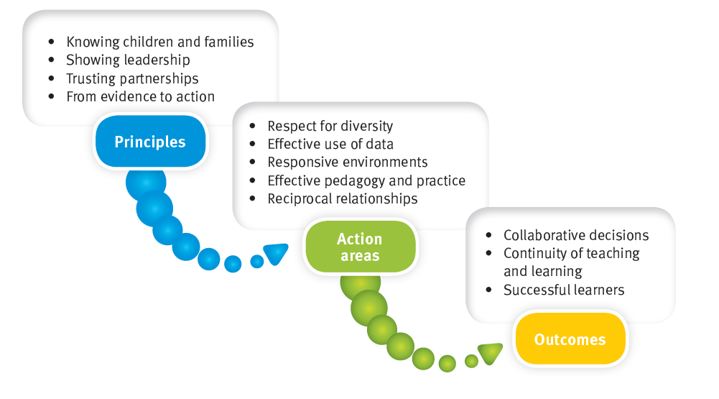
The role of schools
Schools have a responsibility to plan and enact transition strategies that will effectively support each child in meeting their individual needs. This statewide transition approach advocates the identification and implementation of strategies focused on school practices and programs to enhance current service
delivery. Local strategies should be sustainable within the resources available to schools. School leaders document their strategies in current school planning documentation e.g. school plan, Great Results Guarantee plan or annual implementation plan. Information for families about transition to school practices should be included on school websites.
Staff Working With Our Kindy Children

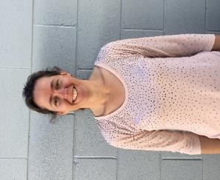
Principal Teacher Teacher Aide Teacher Aide
Mrs Michelle Beresford Miss Aishling Murphy Ms Chris Berghofer Mrs Marg Koop

School Officers That May Engage with Kindy Children
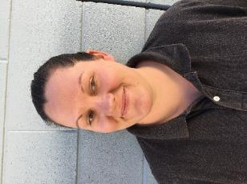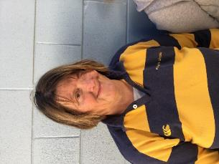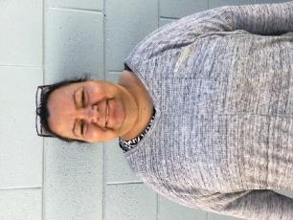
Grounds Keeper Cleaner Administration Officer
Mrs Mel White Ms Carmel Smith Ms Debbie Murphy

At Eulo State School, our strategy to support transition to Prep is laid out in matrix below.
Transition to Prep
Supporting a Shared Responsibility for a Successful Transition
ACTION AREA | STRATEGIES/ACTIONS | PARENT/  CARER | SCHOOL | PHASE
Respect for Diversity | - Engage with community leaders to discuss transition practices and clarify  - inclusive strategies.  - Redesign orientation programs with respect to culture, language, traditions and identity.  - Use information about child strengths/likes contained in transition statements to develop a profile of individual students.  - School transition storybook — what children can expect as they transition to school (multiple languages as needed).  - Early engagement with agencies and ECEC services supporting students with disability.  - Outreach programs for rural and remote families — orientation packs for children issued over terms 3 and 4.  - Community mapping to consolidate knowledge of school diversity.  - School-based playgroups delivered by relevant organisations and supported by community leaders and elders. |  |  | Ongoing  Term 3  Term 4  Term 4  As required  Term 4 – KEYS  As required  Term 1, 2, 3, 4
Effective Use of Data | - Local data network comprising school, ECEC services, local agencies and nongovernment  - agencies.  - Working group with local ECEC services to discuss transition statements, with a focus  - on content, what information is provided, what it tells you about students and how it can be used.  - Community consultations in small communities without ECEC services.  - Valuing transition statements — messaging built into orientation materials for families  - (why transition statements are important and how they support the child’s transition).  - Review assessment tools used prior to school — how do they value add? How can  - they be used in conjunction with transition statements to provide a picture of the  - whole child. |  |  | Ongoing  Term 4  Term 4  Term 4  Term 4
Responsive Environments | - Routine times for Prep are responsive to the needs of students.  - Consideration of the location, aesthetics and function of outdoor environments.  - Plan how the learning environment may change across a year to support growth but  - reflect continuity. How will it look in the first month and how will it track at the end of Prep?  - Differentiate for the needs of students.  - Reflect on aspects of Quality Area 3 (Physical environment) of the National Quality Standards and possible application to the school environment. |  |  | ongoing  ongoing  ongoing  ongoing  ongoing
Reciprocal Environments | - Facilitate parent education and information sessions in collaboration with ECEC services.  - Onsite playgroups facilitated by relevant community groups or agencies.  - Move from consultative to collaborative practice.  - Facilitated playgroups in conjunction with parent information sessions.  - Attend ECEC professional development.  - Review relationships with other agencies and services using Quality Area 6 (Collaborative partnerships with families and community) of the National Quality Standard. |  |  | ongoing  weekly  Sem 1 - 2  As available  As available  Term 1 with Strategic Plan
Effective Pedagogy and Data | - Use a range of early years pedagogical approaches (AAP)  - Differentiate learning experiences to enable all students to meet the Australian Curriculum achievement standards.  - Facilitate teacher visiting program in ECEC services.  - Invite local ECEC educators to school-based professional development.  - Compare prior-to-school and Prep pedagogy — plan a continuum of practice to support effective transitions (QKLG/EYLF). |  |  | continuous  ongoing  as available  as available  Term1 and 4

Transition to junior secondary school: transition matrix
Supporting a shared responsibility for successful transitions

Essential elements: | - Whole school approach: students with disability participate in orientation visits and transition programs with all Year 6 students.
 | - Collaborative practices: student, family, teachers, schools, therapists, agencies and the community work together to develop a shared responsibility.
 | - Inclusive practices: identify barriers and adjustments to access, participation and learning.
 | - Family- and student-centred approaches: take into account the needs of the student and the family throughout the process.
 | - Clear communication pathways: establish the best ways to communicate between families, the primary and secondary school.
Phases | Parents/carers | Primary school | Secondary school
Year 6  Term 1 | - Identify local secondary schools.  - Gather local school information from websites, prospectus, information sessions and open days.  - Speak with other families who have children at local secondary schools.  - Discuss options with the primary school. | - Nominate a key transition contact for students with disability.  - Update the register of local secondary schools.  - Establish how best to communicate with local secondary schools.  - Share information with students and families about local secondary schools.  - Document adjustments and consider high school context. | - Nominate a key transition contact for students with disability.  - Update the register of local feeder primary schools.  - Establish communication pathways with local feeder primary schools.  - Provide school information to local primary schools.
Year 6  Term 2 | - Tour local secondary schools and consider taking a friend with you.  - Identify subjects offered by the school that may interest your child, e.g. business.  - When you have made your decision about where to enrol your child, collect the enrolment package, begin to complete the forms and share your decision with the primary school.  - Collect any reports and documentation that will help the school understand your child’s strengths and needs. | - Work with families to gather relevant information.  - Make secondary school information available to families.  - Advertise local secondary school open days and information sessions.  - Communicate with parents/carers about the transition to junior secondary at parent/teacher meetings and in year level meetings and email groups. | - Provide students and parents/carers additional information and/or school tours if required.  - Advertise school social events to encourage cluster schools and families to become familiar with your school.  - Update enrolment packs and ensure information on support services available at the school is included.  - Advertise enrolment pack availability on school signs, in newsletters and with local primary schools.
Enrolment phase | - Make an appointment for an enrolment meeting  At the enrolment meeting:  - discuss orientation visits and transition activities that will be provided to support your child.  - share information about the strengths, interests and needs of your child.  - arrange to give the school any plans that are relevant.  - share important medical information.  - provide the school with the contact details of current teachers, therapists and other key personnel.  At the enrolment meeting an additional meeting referred to as a transition meeting may be suggested by you or the school. You can nominate people to attend the transition meeting who will be able to share additional information about your child. | - Provide information to the parents/carers that may be shared at the enrolment meeting.  - Follow-up with the family after the enrolment meeting.  - Follow-up with the secondary school after the enrolment meeting to determine if any more information needs to be provided. | - Add parent details to the school’s mailing list, to encourage family involvement in the school e.g. theatre production, school fete.  - Provide the parent/carer with information on supports available at the school including the school learning and wellbeing framework.  - Determine if a transition meeting is required.  - Refer to OneSchool help guides to determine what actions, if any, need to be undertaken in OneSchool.  - Use the guide to complex case management to determine if a complex case meeting is required.
Transition meeting | - Consider bringing a friend or family member to the meeting.  - Share information on your child’s educational, social and emotional needs.  - Ask questions about the challenges your son or daughter may face in the more complex and different secondary school environment.  - Discuss how you can best support your child through this transition period.  - Determine how best to communicate with the secondary school. | - Provide information and data to the family that may be shared at the transition meeting.  - Communicate with the secondary school to assist in determining if any and what type of, additional orientation visits and transition programs will support the student. | If a transition meeting is required:  - organise and facilitate the meeting  - include participants nominated by the parent  - share information, strategies and insights in order to better understand the student and their educational, social and emotional needs  - discuss the challenges that may be faced by the student in the more complex secondary school environment and discuss strategies with the parent/carer that will support the student  - determine additional orientation visits and transition programs that are flexible and responsive to the student’s needs  - discuss community contacts and links as required.
Year 6  Term 3 & 4 | - Encourage your child’s participation in all orientation visits and transition programs.  - Organise additional visits to the school for yourself or members of your family as needed.  - Discuss the secondary school with your child in a positive way and talk about any concerns your child may have.  - Collect any resources developed during the transition program that you can use to support your child over the holidays.  - Make sure you have the contact details of relevant staff at the school.  - Encourage your child to become involved in extra-curricular activities as an additional way to develop a sense of belonging in the secondary school.  - Gather tips from the school and friends on helping your child become more organised and independent at secondary school. | - Students undertake orientation and transition visits along with their age peers to become familiar with the new school.  - During orientation and transition visits, primary and secondary teachers work with the student to complete transition activities e.g. transition booklet.  - Schools plan in response to information and data.  - Schools collaboratively develop and align classroom and student management practices during the transition period.  - Link transition activities with cross curricula and general capabilities and highlight the following:  - social and relationship skills  - organisational skills  - study skills  - self-determination skills  - self-advocacy skills  - leadership skills.  - Schools review, reflect and align their transition processes using the Learning and wellbeing framework: School Planning and Evaluation Tool to support social and emotional skills as an integral part of transition.  - Determine if secondary school enrichment and extension programs offered as part of the orientation activities e.g. science programs, maths and/or sport are appropriate for the student. | Schools plan in response to information and data.  - Determine the frequency and type of orientation and transition visits, taking into account the individual learner.  - Ensure that the family and the student are aware of the schedule of planned activities, what to bring, where to go, and start and finish times.  - Schools collaboratively develop and align classroom and student management practices during the transition period.  - Determine how best to communicate with and share information, strategies and adjustments gathered with relevant staff.  - Embed collaborative strategies in planning, teaching and assessing across subject areas. Consider:  - co-planning units of work  - co-teaching  - co-assessing  - Determine professional learning needs of staff e.g. teacher aides supporting students with disability learning program.  - Collaborate with specialist staff to plan, prepare for and record adjustments to the learning environment and facilities and determine equipment, resource and transport assistance needs.  - Schools review and reflect on their transition processes at the beginning and end of each transition cycle.

Over the holidays – parents/carers | Label school books and resources clearly to assist your child to locate and organise items as they move from classroom to classroom during the busy secondary school day.
 | Read any information provided by the secondary school with your child e.g. the transition booklet.
 | Make connections with other families who will be attending the same secondary school.
 | Travel to and from the school a number of times to familiarise your child with the route.
 | Identify study area at home and assist with packing and unpacking the school bag to assist with organisational skills.
 | Link with school and community services and programs e.g. local library, sporting activities, arts programs.
Year 7  Term 1 | Parents/carers | Secondary schools
 | - Have school timetables and special events visible at home.  - Assist in developing organisational skills with your child.  - Communicate with the school any concerns or questions you may have. In particular:  - social and relationship issues  - organisational skills  - study skills  - self-awareness and advocacy skills  - homework  - changes in behaviour. | - Provide whole-of-school Disability Standards for Education training as required.  - Continue to communicate strategies and adjustments gathered during the transition program and share planning with relevant staff e.g. teacher aides, therapists, teachers.  - Refer to OneSchool help guides to determine what actions, if any, need to be undertaken in OneSchool, including plans, records of contact, intervention programs and facility and environmental adjustments  - Monitor and support students using the Learning and Well-being framework as a guide.  - In particular:  - wellbeing is built into the school  - inclusive practices are adopted  - structured support for wellbeing is offered  - mentors and buddies are provided  - regular feedback is sought from the student to ensure the student voice is heard  - positive relationships are a focus in the school.

